SC2104 Lab 4 Report

Dayna Chia U2121962L [SE4]

**2.2 Step response – Fixed PWM control loop**

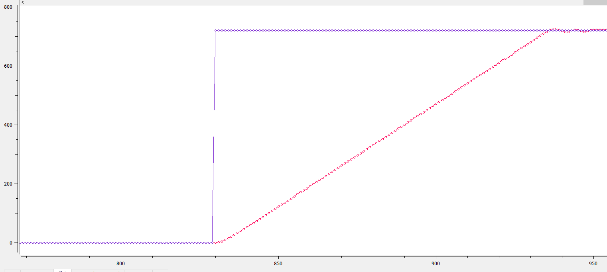

1. pwmVal = 1000

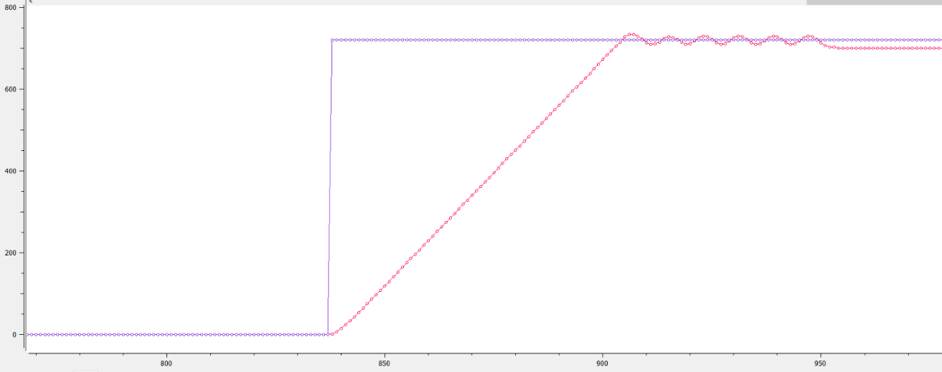

1. pwmVal = 1500

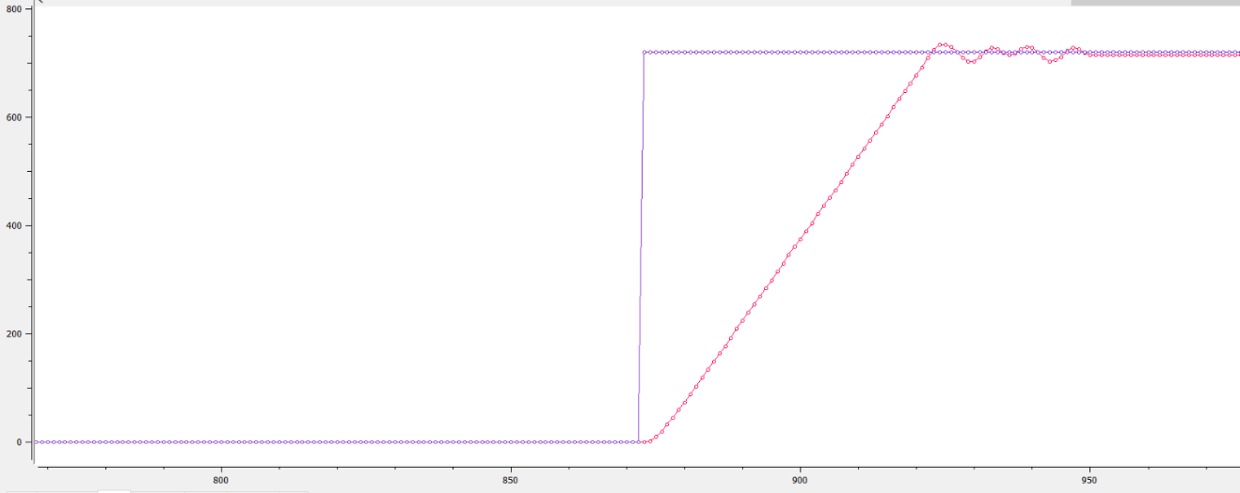

When PWM value increases, rise time decreases. This is because for a larger PWM value, the duty cycle is higher and more power is delivered to the motor. Thus, it takes a shorter time to reach the target angle since the motor spins faster.

1. pwmVal = 2000

**2.3 Step response – PID control loop**

a. Proportional Gain Kp

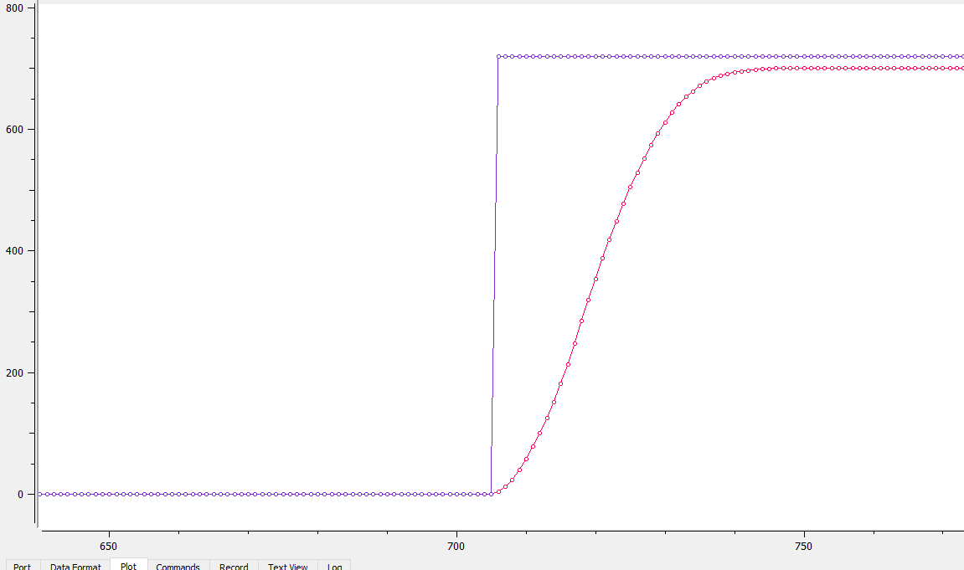

Compared to the responses in 2.2, the shape of the waveform is no longer linear but a curve.

This is because the change in output angle is proportional to the error (difference between target angle and output angle). As the output angle gets closer to the target angle, error decreases and rate of increase of output angle decreases. Thus, the output angle is increasing at a decreasing rate.

1. Kp = 10

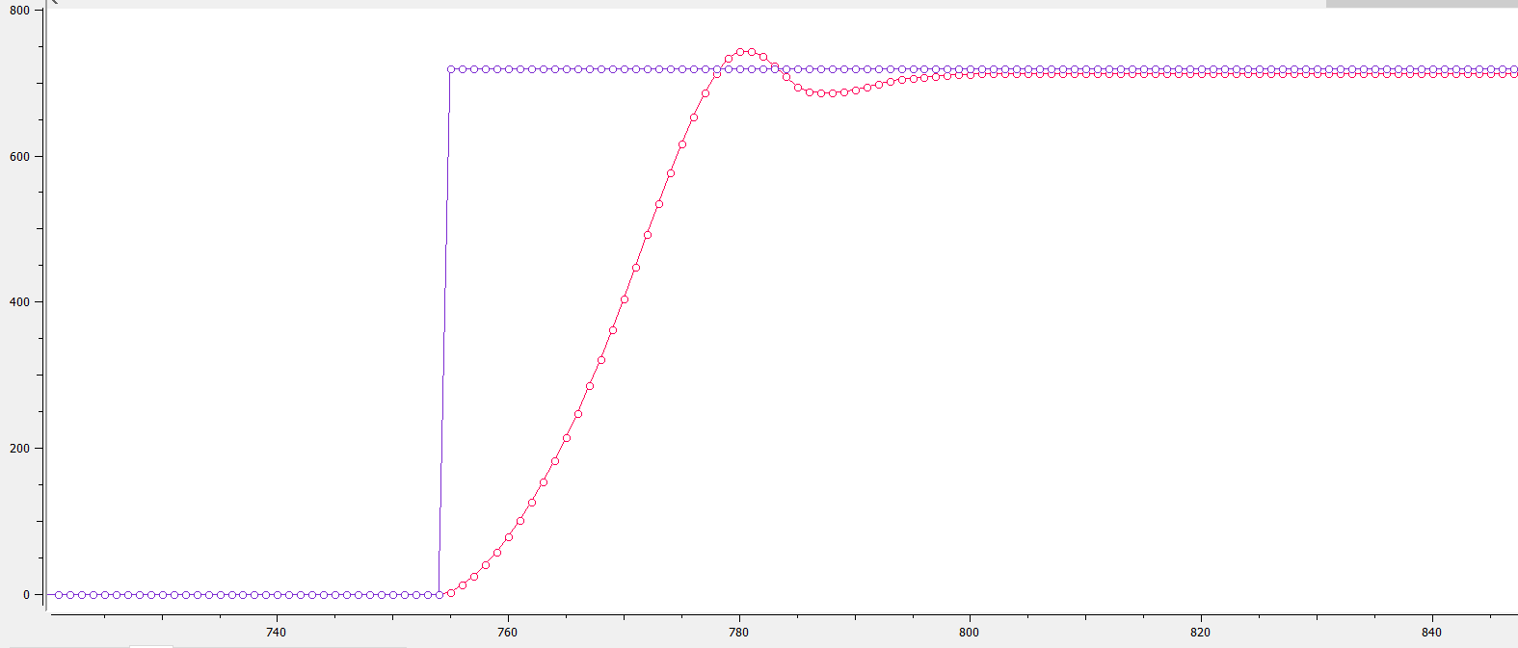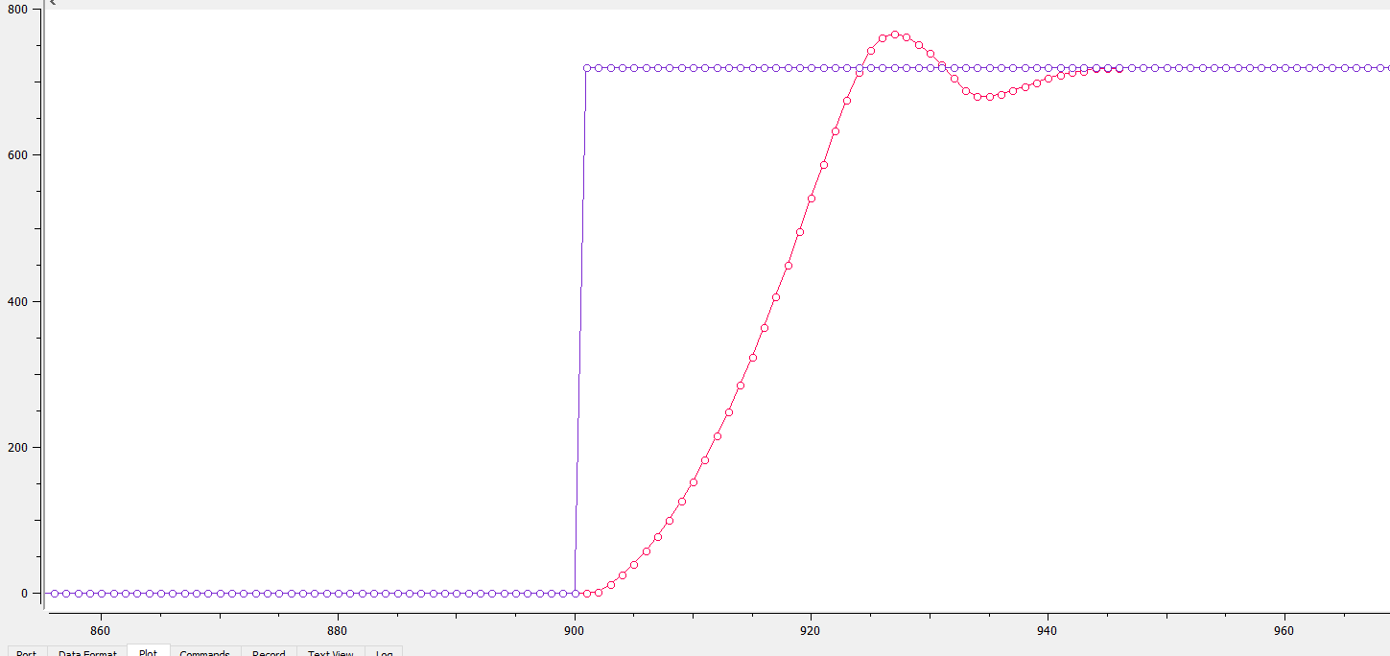

1. Kp = 20
2. Kp = 30

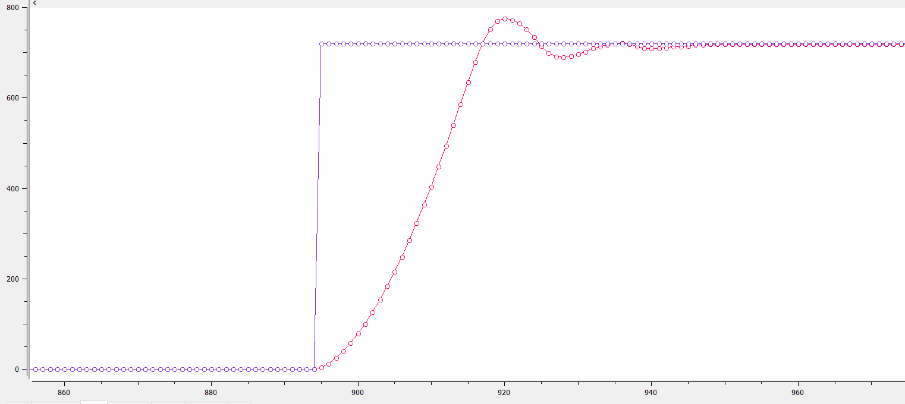

As Kp increases,

Rise time decreases: Change in output angle is greater with larger values of Kp, so output angle increases faster.

Overshoot increases: Increase in output angle is greater

Steady state error decreases

Oscillation increases: Oscillation occurs when target angle is overshot, overcorrected and overshot again. Overshoot and overcorrection is larger with a larger Kp value.

1. Kp = 40

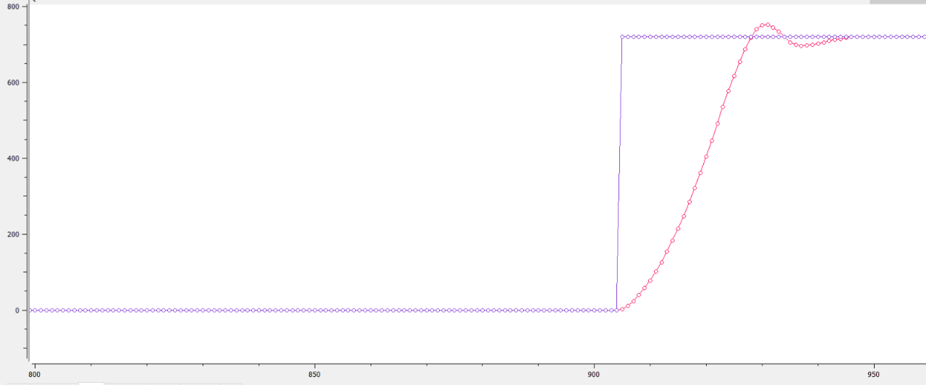b. Integral Gain Ki

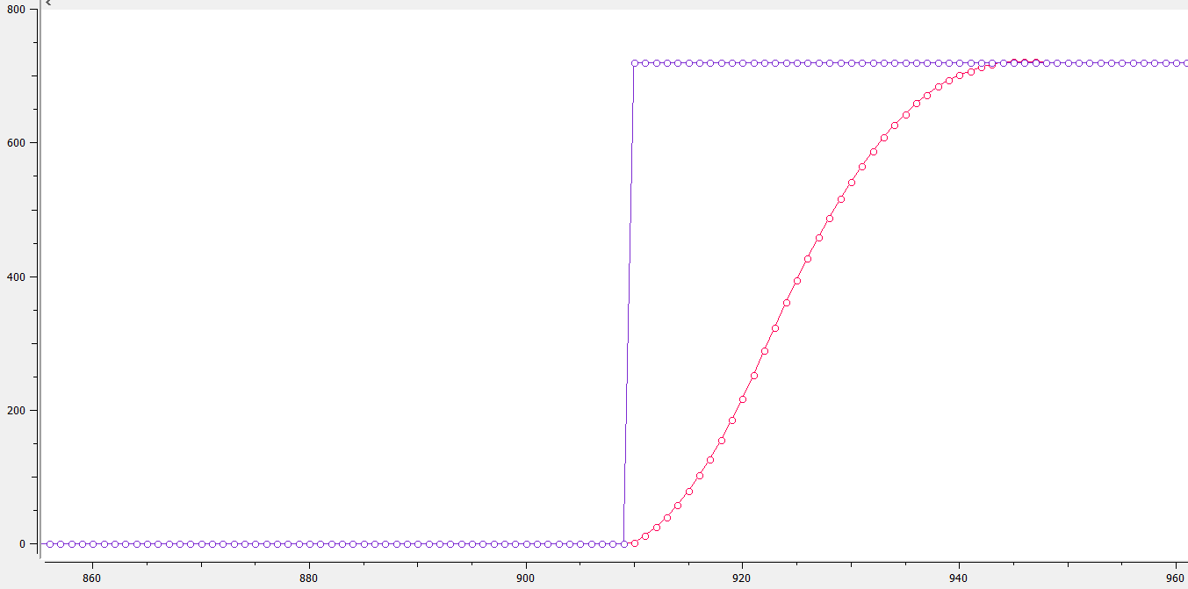

1. Ki = 0.001,

Kp = 20

1. Ki = 0.001,

Kp = 10

Compared to the responses in (a),

Steady state error is eliminated.

With the introduction of an integral term in which the integral component sums the error over time, even a small error term causes the integral component to increase, albeit slowly. Thus, unless the error = 0, the output angle will continue to increase until it reaches the target angle, so there is no steady state error.

Using a PI controller ensures that the response reaches the final steady state value, as seen in the waveforms where the output angle eventually reaches the target angle.

c. Differential Gain Kd

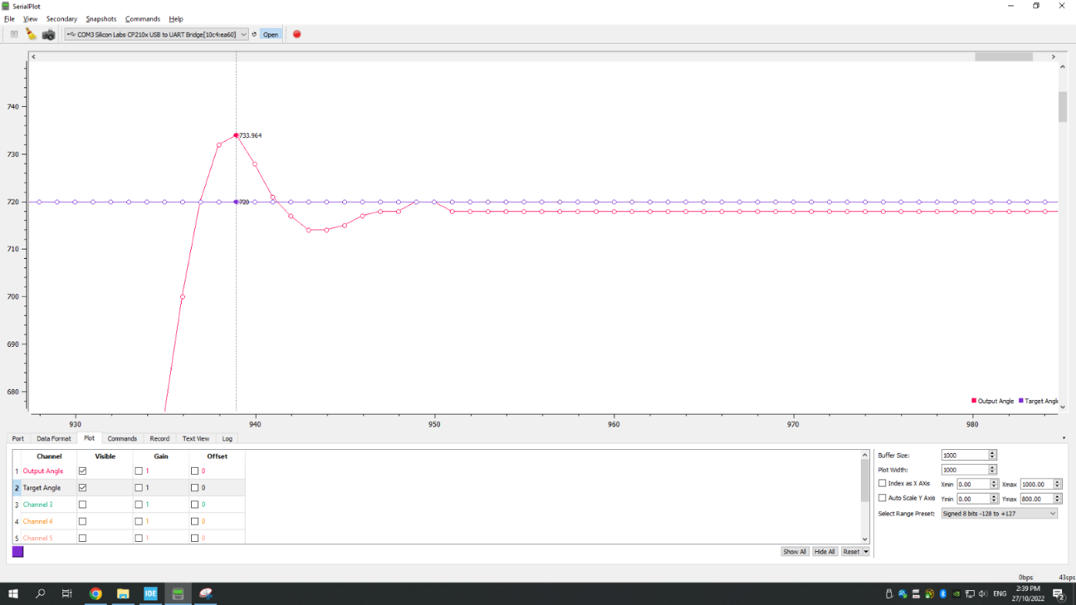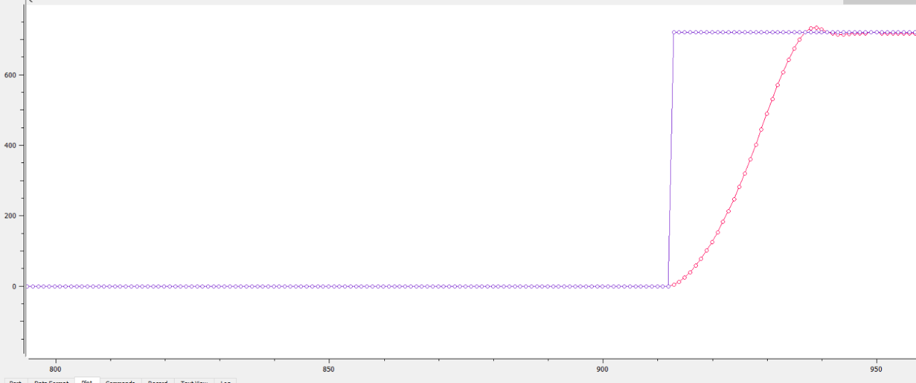

1. Ki = 0.001, Kp = 20,

Kd = 500

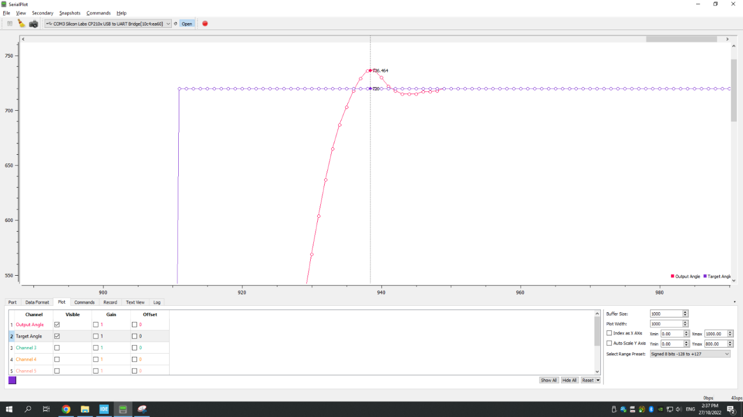

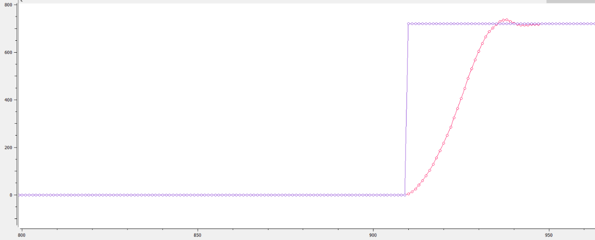

Compared to the responses in (b) and as Kd increases,

Overshoot decreases and settling time decreases.

With the introduction of a derivative term, the controller now has a derivative component that is proportional to the rate of change of error. The system will respond to even a small error change, even if the magnitude of error is small. Whereas for a proportional controller, the response will only change significantly if magnitude of error is significant. As such, a controller with the addition of a derivative term is an anticipatory controller that is able to “anticipate” changes in response.

The derivative response has a damping effect on the system. As the output angle approaches the target angle, input action is reduced, results in the reduction of overshoot.

Oscillation decreases as overshoot and overcorrection is reduced as compared to a system without a derivative component introduced. Since oscillation is reduced, time taken for output angle to reach a steady state is reduced and settling time is shorter.

1. Ki = 0.001, Kp = 20,

Kd = 1000